
YEAR 12 GENERAL HUMAN BIOLOGY

Task 2: Skeletal System Test

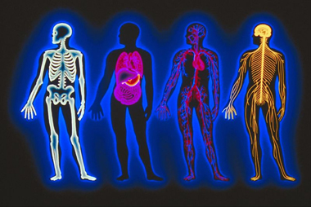

Multiple Choice: 10 marks
Short Answer: 50 marks
TOTAL 60 MARKS

Name :_______________________________

Section A: Multiple Choice (15 Marks)
Answer all questions by placing and X through the most correct answer on the multiple choice answer sheet.

- The vertebral column, rib cage and skull form the:

(a) axial skeleton.
(b) pectoral girdle.
(c) appendicular skeleton.
(d) pelvic girdle.

- The type of joint illustrated by the head on the spinal column is a:

(a) ball and socket.
(b) hinge.
(c) pivot.
(d) partially moveable.

- The bones of the lower limb do NOT include the:

(a) metatarsals.
(b) tibia.
(c) scapula.
- fibula.

Diagram below refers to questions 5 and 6
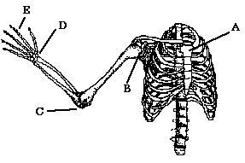
- Which of the above is a hinge joint ?

(a) A.
(b) B.
(c) C.
(d) D.

- Which one of the following pairs of movements is possible at the joint named E?

(a) flexion and abduction.
(b) extension and rotation.
(c) extension and adduction.
(d) flexion and extension.

- The shaft of a long bone is called the:

(a) epiphysis.
(b) diaphysis.
(c) periosteum.
(d) central column.

- The function of synovial fluid is to:

(a) maintain strong ligaments.
(b) allow friction-free movement in joints.
(c) provide added strength to joints.
- lubricate the tendons.

- The major mineral elements deposited in bone are:

(a) magnesium and calcium.
(b) phosphorous and calcium.
(c) phosphorous and magnesium.
- phosphorous, magnesium and calcium

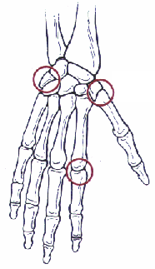
A
Refer to the diagram opposite
9). The joint labelled A
(a) Saddle joint
(b) Hinge Joint
(c) Pivot joint
(d) Ball and socket

10). The spongy bone part of a long bone is responsible for
(a) production of blood cells.
(b) storage of fat.
(c). secretion of synovial fluid.
(d). storage of proteins.

End of Multiple Choice Section

Total: 6 marks

Question 17:
Label the following diagram

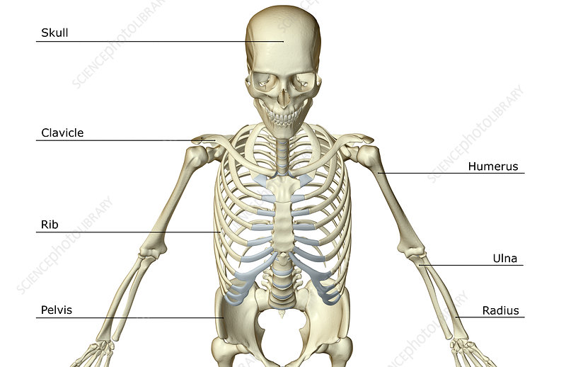

Total: 6 marks

Question 18 refers to the diagram below
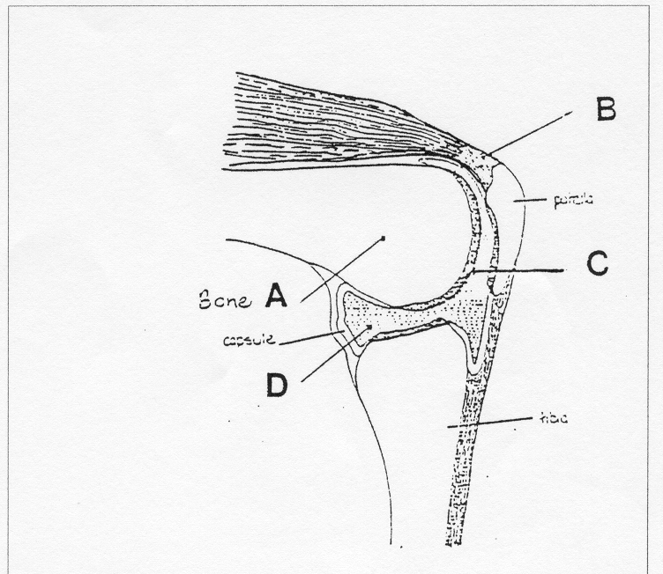
- Label the structures A, B, C and D in the spaces provided below.

A ____________________________ C_____________________________

B ____________________________ D_____________________________

(4 marks)
b. Describe the function of structure C
________________________________________________________________________________________________________________________________________________________________________________________________________________________
(1 mark)
b. The type of joint illustrated above is a synovial hinge joint. Name two other types of synovial joints and give an example of where they are found.
i)_______________________________________________________________
ii)_______________________________________________________________
(2 marks)

c. Name and Describe the three categories of joints found in the body (6 marks)

Joint | Description

Total: 13 marks

Question 19.
Below is the structure of a long bone
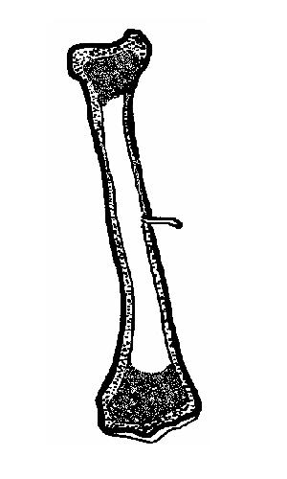
A
B

a) Label the types of bone predominant in areas A and B (2 marks)
A. ____________________________________
B. ____________________________________

b) Describe one way in which the structure of the long bone is suited to the following functions of the skeleton (4 marks)

Function | Description
Support
Movement
Storage
Blood cell production

Describe how a long bone grows (4 marks)
________________________________________________________________________________________________________________________________________________________________________________________________________________________________________________________________________________________________________________________________________________________________________________________________________________________________________________
Total:10 marks


YEAR 12 GTHBY HUMAN BIOLOGY
Task 2: Skeletal System Test
SCORES:
MC: /10
SA: /50
TOTAL: /60
_______ %

NAME:_____________________________
TEACHER:__________________________
DATE:______________________________
Section A: Multiple choice (10 Marks)
Answer all questions by circling the most correct answer on the multiple choice answer sheet.
1. a b c d
2. a b c d
3. a b c d
4. a b c d
5. a b c d
6. a b c d
7. a b c d
8. a b c d
9. a b c d
10. a b c d

